Multi-layer Perceptron (MLP)

- These networks have one or more hidden layers between the input and output layers, allowing them to capture more complex patterns.

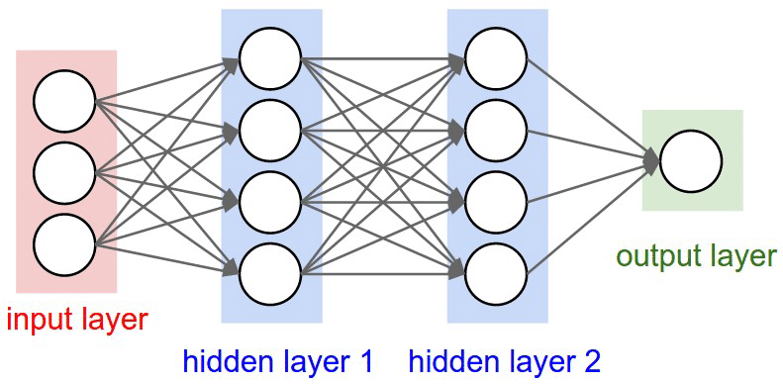

Important technical terms
- Batch Size:
The number of samples (rows) processed at once before updating the model.
- Epoch:
One epoch means the model has seen all the training data once.
- Iteration (Steps per Epoch):
One iteration means the model has processed one batch of data.
The number of iterations per epoch depends on the total dataset size.
- Early Stopping:
Training can be stopped early if the model's performance on the validation set stops improving.

Commonly Used Activation Functions:
- Sigmoid:
  - Output: (0,1)
  - Suitable for binary classification but can suffer from vanishing gradients.
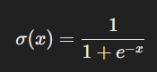
- Tanh:
  - Output: (−1,1)
  - Centered around zero, which can help in optimization compared to sigmoid.
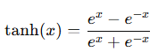
- ReLU (Rectified Linear Unit):
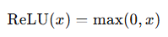
  - Output: [0,∞)
  - Efficient and widely used in hidden layers.
  - Can suffer from "dying neurons" where gradients become zero.
- Leaky ReLU:
  - Output: [0.01x,∞)
  - A variant of ReLU that allows a small gradient for negative inputs, mitigating the dying neuron problem.
- Softmax:
  - Used in the output layer for multi-class classification.
  - Converts logits into probabilities.
